**HOSPITAL MANAGEMENT SYSTEM**

|  |  |  |
| --- | --- | --- |
| Shiven Narang  *Chitkara University*  *Institute of Engineering and Technology* | Shivansh Sharma  *Chitkara University*  *Institute of Engineering and Technology* |  |
| *Chitkara University, Punjab, India*  *Email – shiven835.be22@chitkara.edu.in* | *Chitkara University, Punjab, India*  *Email – shivansh832.be22@chitkara.edu.in* |  |
|  |  |  |
|  | . |  |
| Sneha Pal |  |  |
| *Chitkara University*  *Institute of Engineering and Technology* |  |  |
| *Chitkara University, Punjab, India*  *Email – sneh996.be22@chitkara.edu.in* |  |  |
| Dr. Sunil Gupta  *Chitkara University*  *Institute of Engineering and Technology*  *Chitkara University, Punjab, India*  *Email – sunil.gupta@chitkara.edu.in* |  |  |
|  |  |  |

Abstract

*The purpose of the project entitled as “Hospital Management System” is to computerize the front office management of hospital to develop software which is user friendly simple, fast, and cost effective. The main function of the system is register and store patient details and doctor details and retrieve these details as and when required and also to manipulate these details meaningfully. Traditionally, it was done manually. The Hospital Management System can be entered using a username and password. It is accessible by an Admin, Doctor, & Receptionist. Only they can add data to the database. The data can be retrieved easily. The data are well protected for the personal use and makes the data processing very fast. Government of India has still aimed at providing medical facilities by establishing hospital. The basic working of various hospitals in India is still on paper as compared to hospital in European countries where computer have put in to assist the hospital personals their work. The concept of automation of the administration and management of hospital is now being implemented in India also, with large hospital like APPOLO and AIIMS in Delhi, ESCROTS in Chennai, having automated their existing system. Computers are not only used to increase the efficiency in all fields ranging from fixing the appointment with the Doctor to keeping the records of the patient.*

1. **INTRODUCTION**

Health of citizen is the wealth of nation. India has contributed the most ancient medical science “ayurveda” to the world besides other medical sciences. this field has witnessed a rapid metamorphosis in all of its sections. hospital management system is designed to improve the quality and management of hospital in the areas of clinical process analysis and activity-based costing.

Hospital management system enables you to develop your organization and improve its effectiveness and quality of work. Managing the key processes efficiently is critical to the success of the hospital helps you manage your process. The hospital management system can be entered using username and password.it is accessible by an admin, doctor & receptionist. Only they add data to the database. The data can be retrieved easily. The data are well protected for personal use and makes the data processing very fast. Hospital management system is powerful, flexible, and easy to use and is designed and developed to deliver real conceivable benefits to hospital. The project hospital management system includes registration of patients, storing their details into the system using database. The software has the facility to give a unique id for every patient and stores the details of a patient using the name id. Hospital management system is designed for multi specialist hospital, to cover a wide range of hospital administration and management processes. The system also provides excellent security of data at every level of user system interaction and also provides robust and reliable storage facilities.

1. **WORKING METHODOLOGY**

The entire project mainly consist of 5 modules, which are:-

**ADMINS**

1. Admin activity

2. Doctor management

**DOCTORS**

1. Appointment

2. Add doctor

3. Delete doctor

4. Search doctor

5. Update doctor

6. View doctor

**MAIN**

1. Admin

2. Doctor

**PATIENT**

1. Delete patient

2. Add patient

3. Patient activity

4. Search patient

5. Update patient

**III.Results**

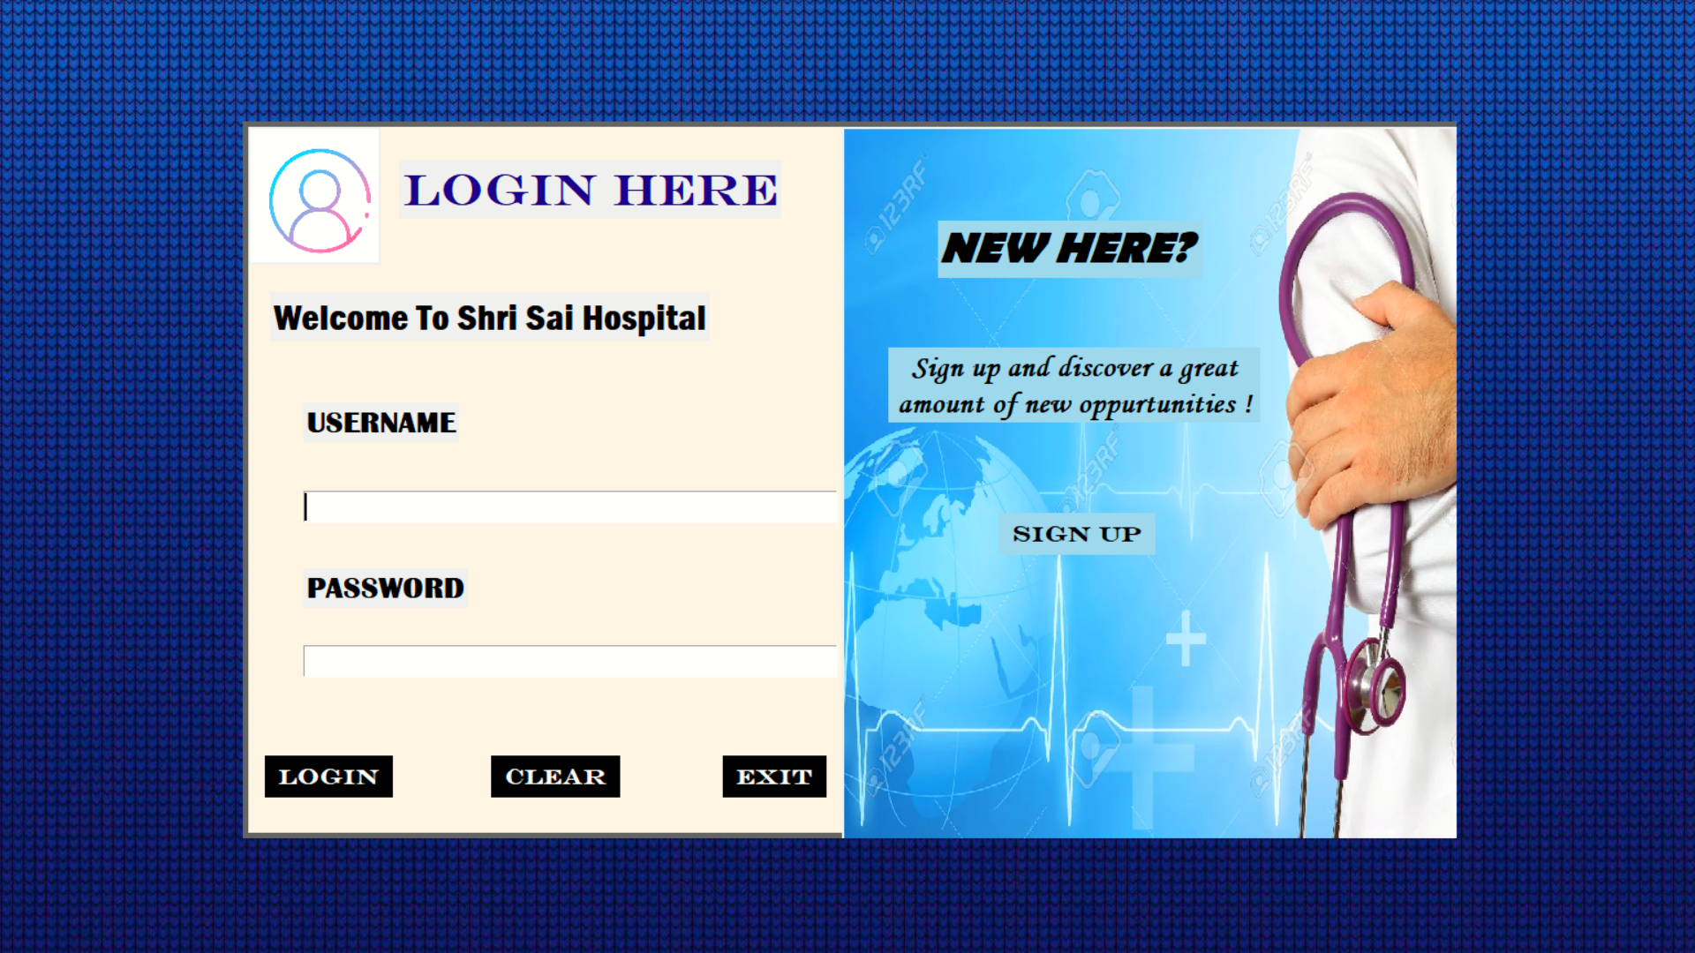

Figure 3.1:- There is a login page which is common for each module. User of each module must go through this pagewith their own user id and password.

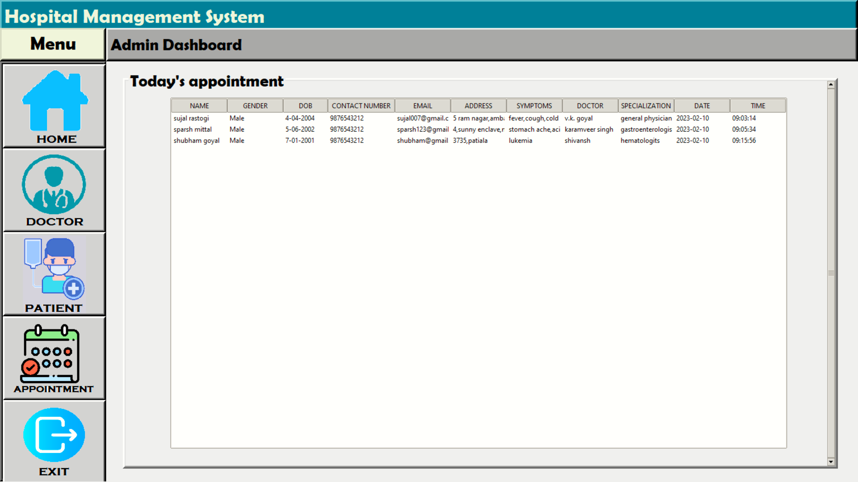

Figure 3.2 :- shows Patients Registration. In this page registration of patients is done by using their details like name, address, mobile no., etc

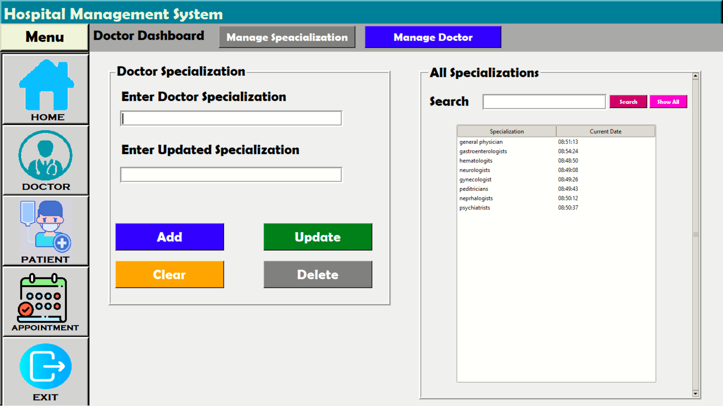

H

Figure 3.3:-Here we can add and update doctor specialization.

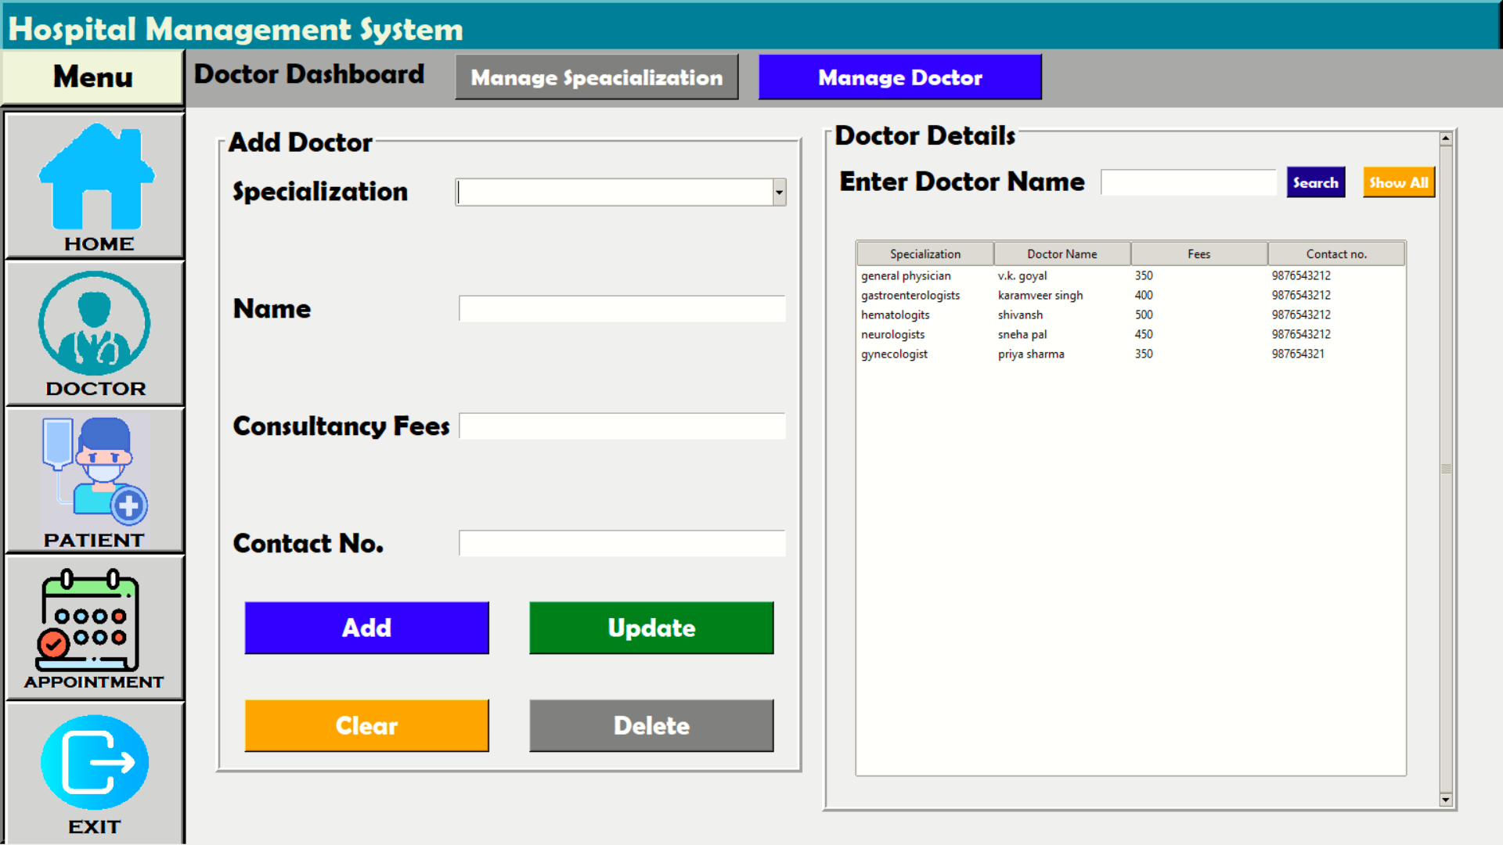

F

Figure 3.4 :- Here we can add all details of doctor like contact no.,fees etc.

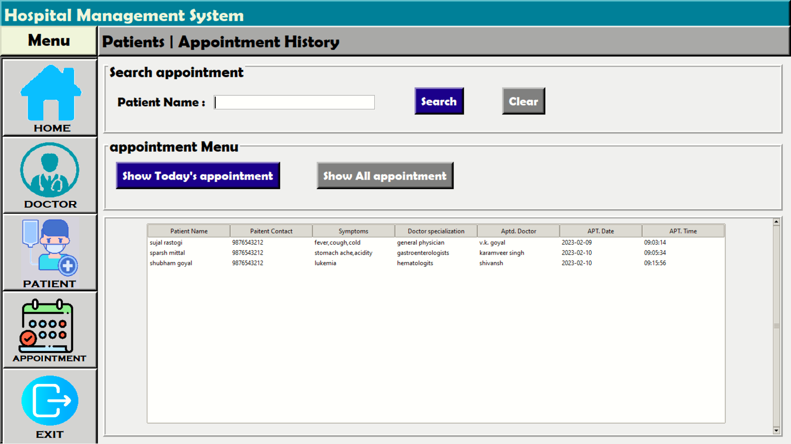

F

F

Figure 3.5 :- This page helps to manage patients queue by using name of doctor, appointment time and slot.

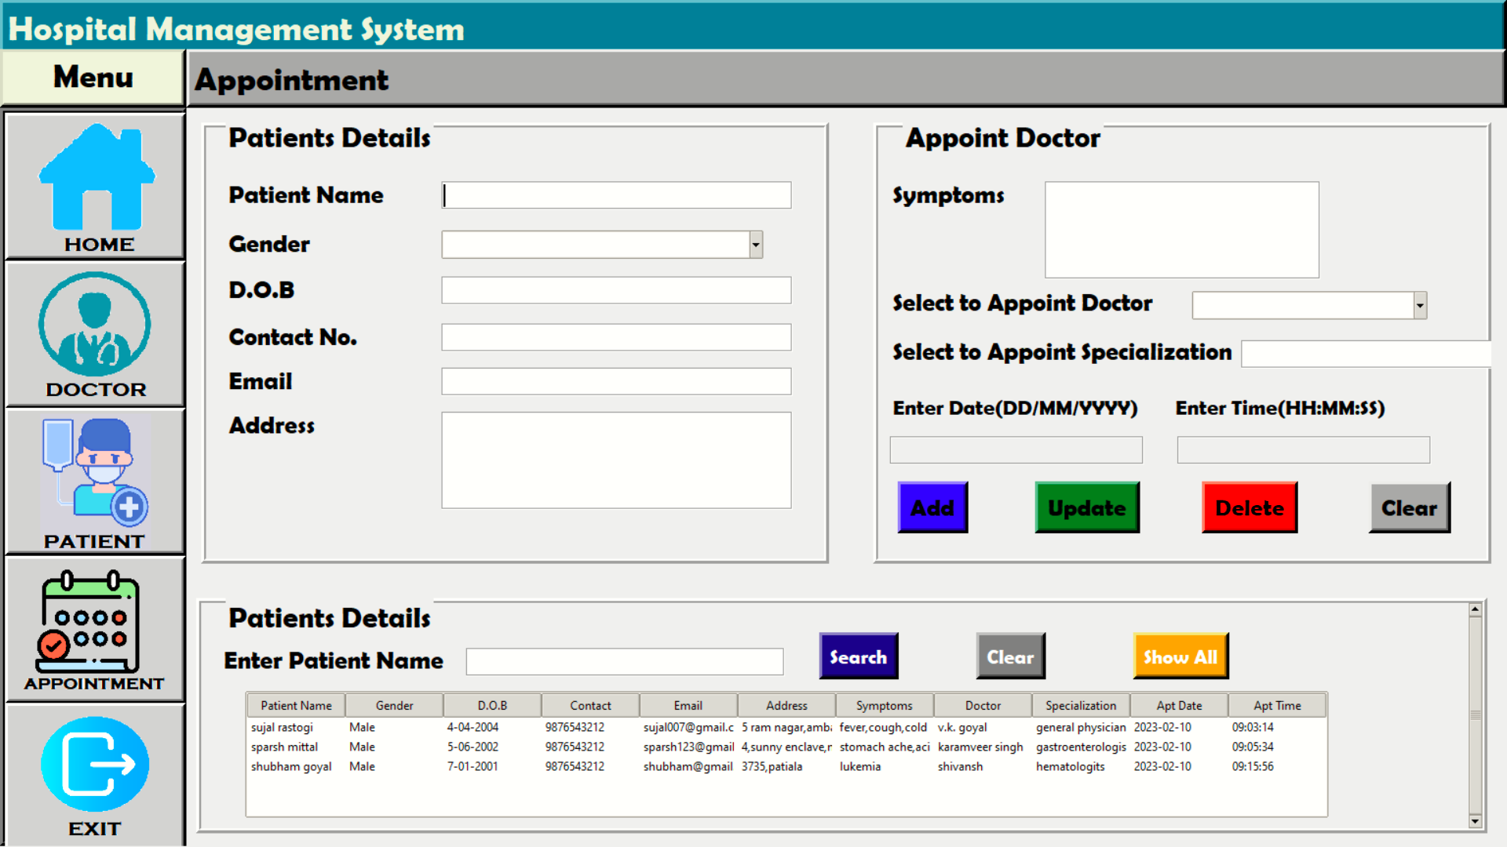

Figure 3.6 :- This page is used to fix appointment of patient.

Backend using sqlite3

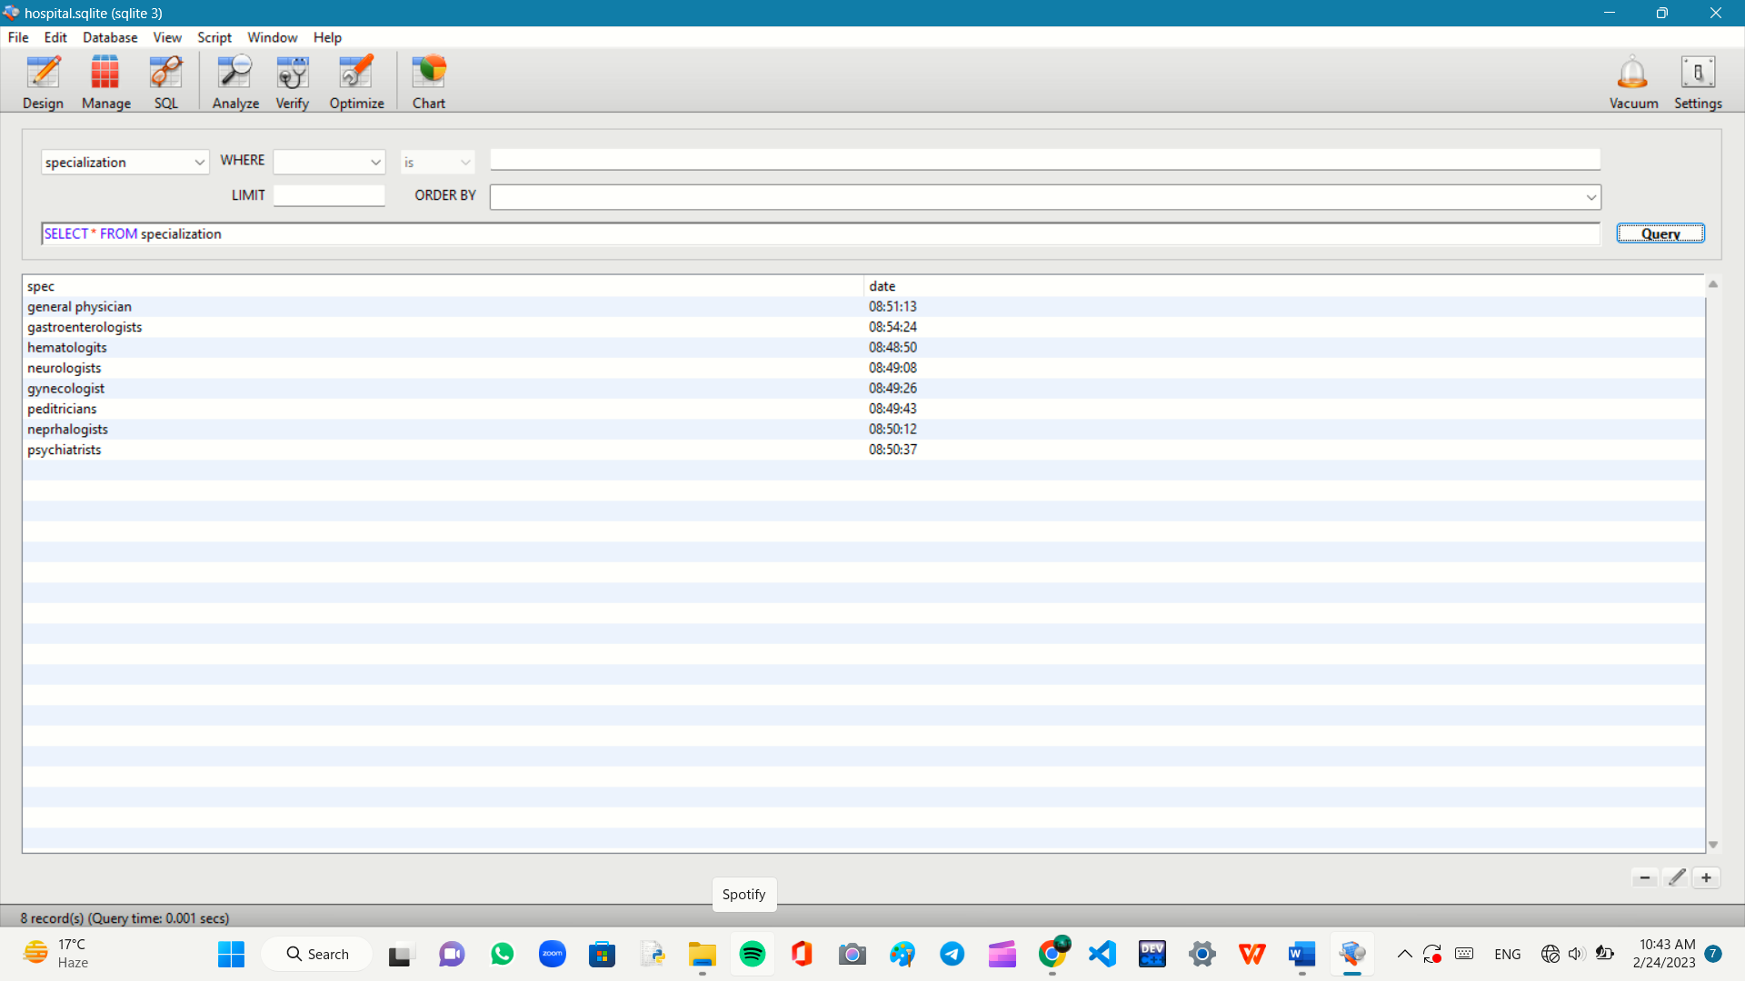

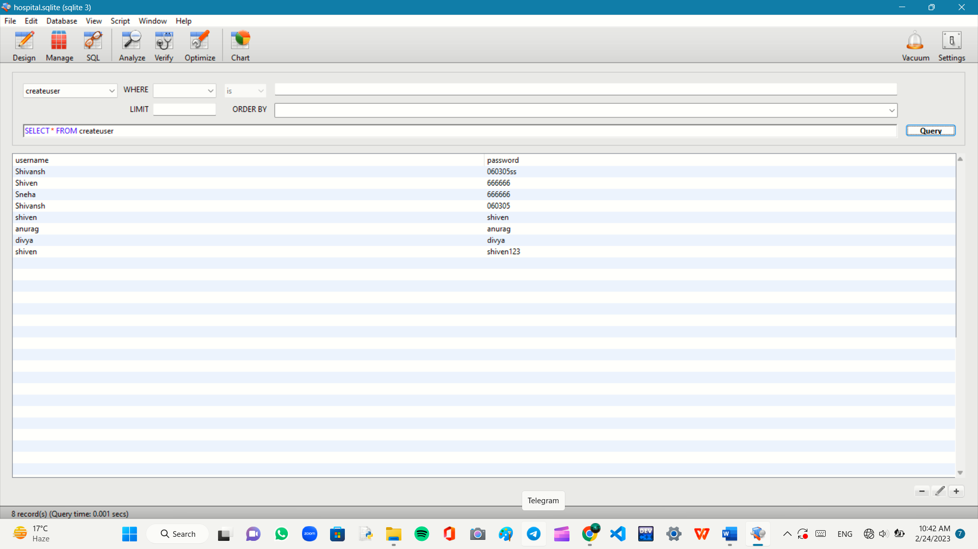

**IV. SYSTEM ANALYSIS**

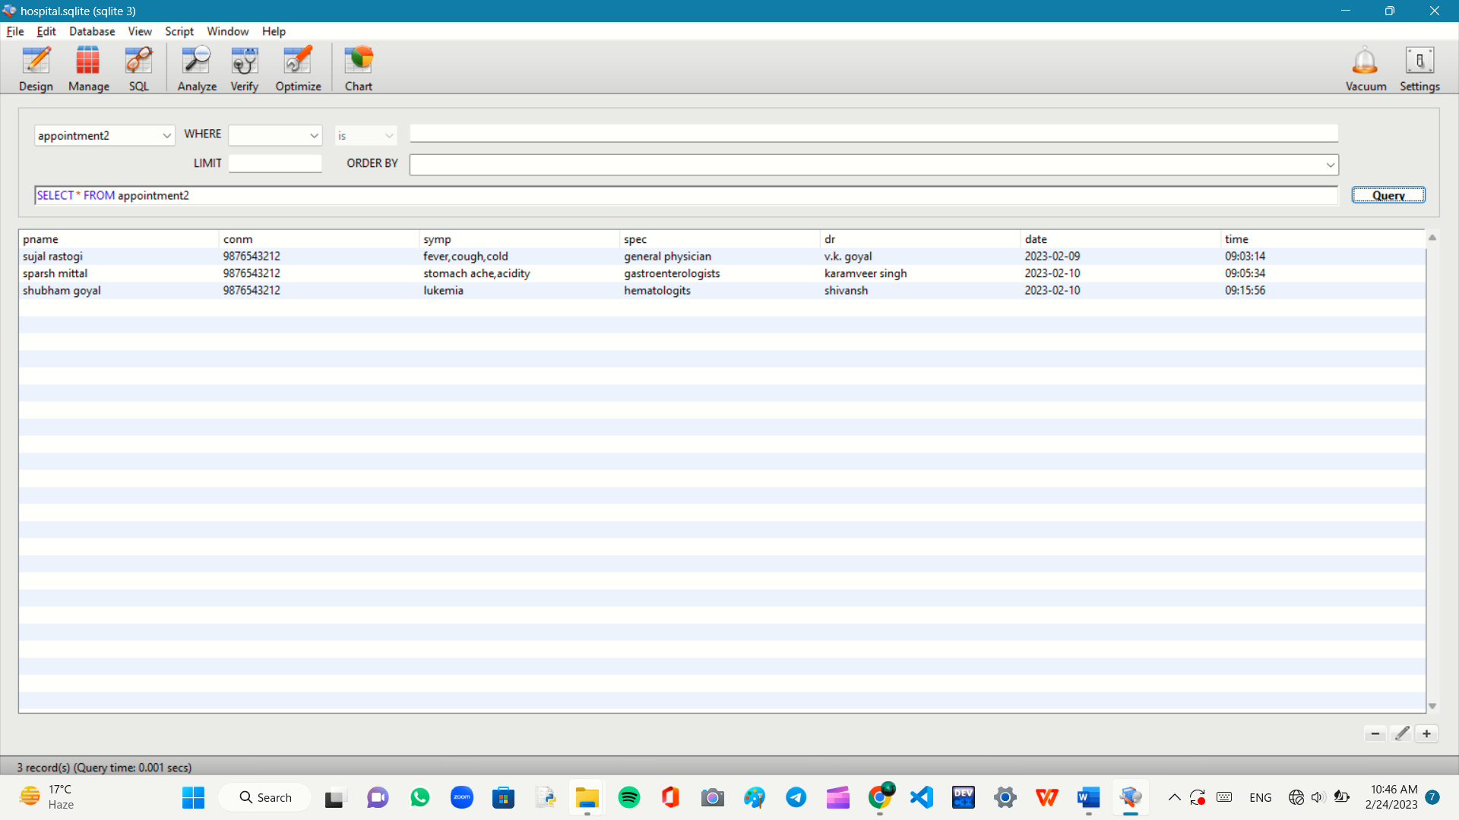

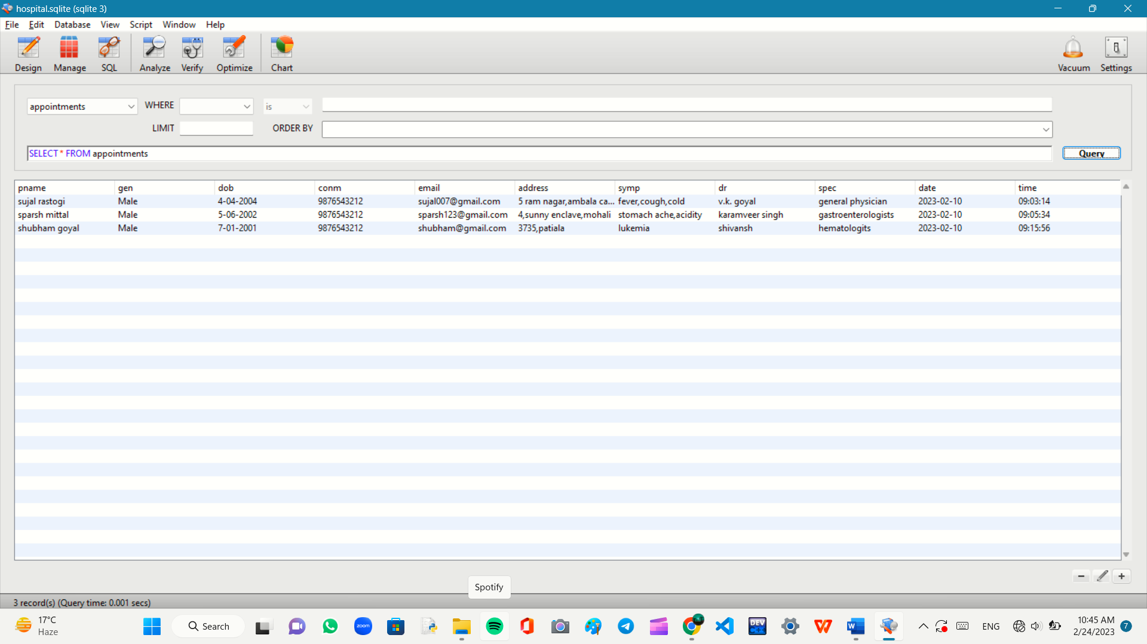

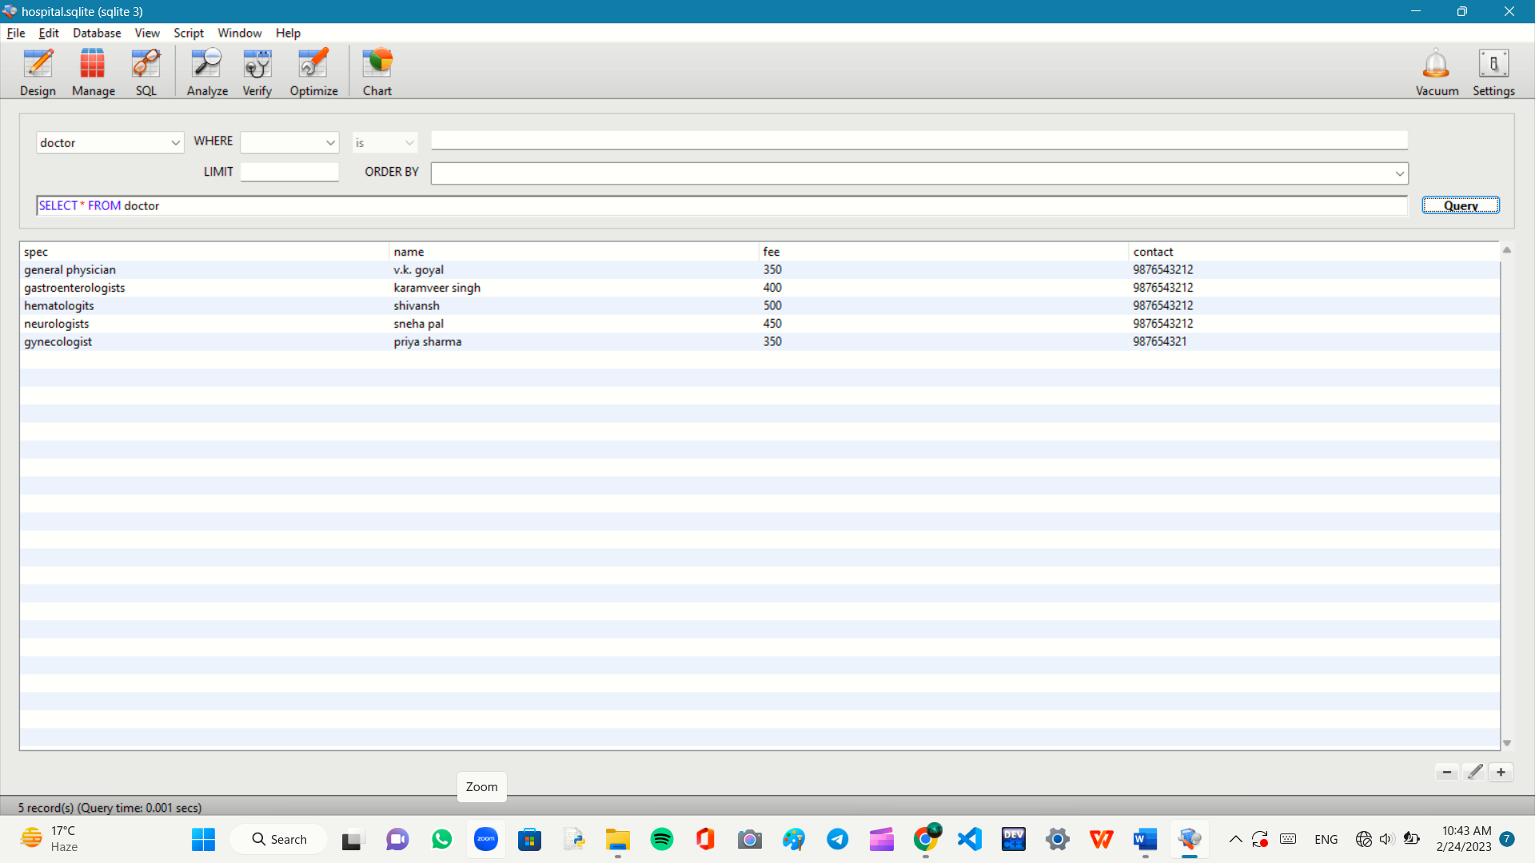

**2.1 EXISTING SYSTEM** :- The current manual system has lot of paper work.To maintain the record of sale and service manually, is a Time- consuming task.With the increase in database, it will become a massive task to maintain the database. Requires large quantities of file cabinets, which are huge and require a quite a bit of space in the office,which can be used for storing records of previous details. The retrieval of records of previously register patients will be a tedious task. Lack of security of the records of your system. If someone wants to check the details of the available doctors the previous system does not provide any necessary details of this type. All this work done manually by the receptionist and other operational staff and lot of papers are needed to be handled and taken care of. Doctors have to remember various medicines available for diagnosis and sometimes miss better alternatives as they can’t remember them at that time.

**ADVANTAGES:-**

1. No extra training required

2. Easy to implement

3. Can be stored anywhere

4. Requires minimum efforts

**DISADVANTAGES:-**

1. Needs a lot of paper work

2. Problem with maintenance

3. Volumes of data becomes problem

4. Once data is burned it cannot be reproduced easily

5. Data handling is problem

**2.2 PROPOSED SYSYTEM**

The hospital management system is designed for nay hospital to replace their existing manual paper-based system. The new system is to control the information of patients as well as doctors. These are to be provided in an efficient, cost-effective manner, with the goal of reducing the time and resources currently required for such task. The complete set of rules and procedure related to the Hospital’s day to day activities and generating report is called “HOSPITAL MNAGEMENT SYSYTEM’. It is a computerized management system. This system also keeps the records of hardware assets besides software of this organisation. The purpose system keeps the track of Doctors, Patients, & Receptionist. This project has GUI based software that will help on storing, updating, and retrieving the information through various user-friendly menu-driven modules.

**GOALS OF PURPOSED SYSTEM**

i.The system should be easy to operate

ii. The working in organisation will be well planned and organized .

1. The level of accuracy in the purposed system will be higher
2. The reliability of the purposed system will be high due to proper storage of information.
3. Provide quick and efficient retrieval of information .

**ADVANTAGES:-**

1. Low Maintainance Cost.
2. Volume of data is not an issue.
3. Data can be converted easily with proper backup.
4. Data cannot be corrupted easily with proper backup.
5. It can be expanded as well as data communication is possible.

**DISADVANTAGES:-**

1. High starting cost required.

2. Additional man power is necessary.

3. Data communication system will have an additional cost.

**V. CONCLUSION**

Since we are entering the details of the patients electronically in the “Hospital Management System”, data will be secured. using this application, we can retrieve patient’s history with a single click. Thus, processing information will be faster. It guarantees accurate maintenance of patient details. It easily reduces the book keeping task and thus reduces the human efforts and increases accuracy speed. Hospital management system is essential for maintaining details about the doctor, patient, etc we understand by using of hospital management system project the work become very easy and we save lot of time. Hospital administrator would be able to significantly improve the operational control and thus streamline operations. This would enable to improve the response time to the demand of patient care because it automates the process of collecting, collating and retrieving patient information. Accounting sometimes becomes awfully pathetic and complex. This product will eliminate any such complexity.

**VI. FUTURE SCOPE**

All this work is manually done by the receptionist and other optional staff and lot of papers are needed to be handled and taken care of. Doctors have to remember various medicines for diagnosis and sometimes miss better alternatives as they can’t remember them at time. The limited time and resources have restricted us to incorporate, in this project, only main activities that are performed in the hospital Management System, but utmost care has been taken to make the system efficient and user friendly. Most of the analysis and interpretation, made for this report, are based on secondary data obtained. This data could have some inherit mistakes and errors. Finally, although due care has been taken those can be typing and compilation error in the report itself. The task specified were nit well defined because nothing was mentioned regarding validation in the project. Though we gave maximum efforts to check the software. But it is no way alter the ultimate aim of the project and because it’s highly USER FRIENDLY, it would be the choice of all kind of personnel.